A. NOTES 注意事項
- All questions must be answered. If not applicable, please write “n/a”. You may attach additional sheet(s) if necessary.
所有問題必須作答。如不適用者，請填上「不適用」。如有需要，可附上額外紙張。
- Sections B and C should be fully completed and signed.
詳細填妥本表格B及C部份並簽署。
- Section F is to be completed and signed by the attending Doctor.
本表格F部份由主診醫生填妥並簽署。
- The issue of this claim form is not an admission of liability by QBE Hong Kong.
發出此索償申請表並不代表昆士蘭保險香港承認任何責任。
- If the Insured is unable to write on account of disablement, this form should be completed and signed by a close relative or other responsible person acting on behalf of the Insured for the time being.
如投保人因傷病不能書寫，投保人的家屬或負責人可代為填妥及簽署。
- Original hospital bill, receipt and doctor’s referral letter are submitted together with this form.
住院賬單、收據及醫生介紹書正本應連同此表格一同提交。

B. DETAILS OF THE INSURED 保戶資料
Policy no.  保單編號： |  | Name of the Insured  投保人姓名：
Address
地址：
Email address  電郵地址： | Mobile phone no.  流動電話號碼： |  | Occupation  職業：

C. CLAIM INFORMATION索償資料
Name of patient  病人姓名 |  |  |  | Disease / nature of Injuries  疾病 / 受傷之性質
Period of hospitalization (DD/MM/YYYY)  住院日期 (日/月/年)： | From  由 | Date  日期 | Time  時間 |  | To  至 | Date  日期： | Time  時間：
Date when symptoms first appeared / accident happened (DD/MM/YYYY)  病發 / 意外發生日期 (日/月/年)： / / |  |  |  | Date of receiving first treatment (DD/MM/YYYY)  首次接受治療日期 (日/月/年)：  / /
Cause of the disease / injuries
病發 / 意外之成因：

Has the patient received treatment for the same disease before?  過去有否因此疾病而接受治療？ |  |  |  |  |  |  |  | - Yes 是  - No 否
If “Yes”, please provide the doctor’s name.
如「有」，請提供該醫生姓名。

Is the patient under the regular care and attendance of a physician?  病人有否經常診治的醫生？ |  |  |  |  |  |  |  | - Yes 是  - No 否
If “Yes”, please provide the doctor’s name.
如「有」，請提供該醫生姓名。

Is the patient insured with any other insurance company for hospital benefits?  病人有否投保其他保險公司之住院保障？ |  |  |  |  |  |  |  | - Yes 是  - No 否
If “Yes”, please state the name of the company and the policy number.
如「有」，請列明其公司名稱及保單編號。

注意：若其他保險公司曾作出賠償，請提供該保險公司之賠償證明。
Note: Please provide a copy of the payment document if another insurance company has already paid part of the medical expenses.

D. PAYMENT MODE 收取賠償款項方式
Subject to the terms and conditions of your policy, you may select to receive the claim payable amount by way of direct credit or cheque. Normally, you will receive your payment 3-5 working days earlier if you choose the direct credit option. If you do not provide your payment preference, a cheque will be issued for any claim payment.
在保單條款許可情況下，閣下可選擇以銀行轉賬或支票方式收取賠償款項。一般情況下，選擇銀行轉賬收取賠償款項較支票快 3-5 個工作天。如閣下沒有選擇收取賠償款項方式，將會視作選擇以支票收取賠償款項。
Important Note for Direct Credit 銀行轉賬重要事項
- The claim payment shall be credited to the bank account in the name of the Insured Person in accordance with the terms and condition of your policy. To prevent any unnecessary delay, please make sure the bank account number and account holder name are correct.
有關之賠款將按其保單條款，存入該受保人名下之銀行賬戶。請確保賬戶號碼及賬戶持有人名稱正確，以免引致不必要之延誤。
- If the claim payment is remitted to a third party as a result of your provision of incorrect bank account number and/or account holder name, we shall not be liable to make any further payment and any other additional banking handling charges regardless of whether the claim payment can be recovered.
如索償人提供之銀行賬戶號碼及 / 或戶口持有人名稱不正確，而導致本公司錯誤將賠款存至第三者戶口，無論有關賠
款能否取回，本公司無任何責任再支付該賠款及其引致之相關銀行手續費用。
- Option (1)  選擇（一） | By direct credit – for HKD account only  銀行轉賬 – 只限港元戶口
 | Please provide your bank account details 請提供相關銀行資料
 | Bank Name  銀行名稱 | - Hang Seng Bank恒生銀行  - Others, please specify 其它，請列明：
Name of Account Holder (in English & block letter)
賬戶持有人姓名（英文及以大楷書寫）：
Bank Account Information
銀行賬戶資料：
Bank Code銀行編號 | Bank A/C No. 銀行賬戶號碼

- Option (2)  選擇（二） | Hong Kong Dollar Cheque  港幣支票

E. DECLARATION & AUTHORIZATION 聲明及授權
I / We hereby declare that:
本人 / 我等就此聲明：
- The above information provided by me / us in this from is true and complete to the best of my / our knowledge and belief.
本人 / 我等在此表格提供的資料全是真實正確無訛。
- I / We have not withheld from QBE Hongkong & Shanghai Insurance Limited any information within my / our knowledge connected with the accident / incident.
本人 / 我等就本人 / 我等所知，並未有向昆士蘭聯保保險有限公司隱瞞 / 保留任何有關意外 / 事件資料。
- I / We hereby authorize any medical practitioner, hospital, clinic, insurance company or organization that has any records or knowledge of me / us or my / our health, to furnish to QBE Hongkong & Shanghai Insurance Limited or its authorized representative, any and all information with respect to my / our illness or injury, medical history, consultation prescription or treatment. A photocopy of this authorization shall be considered as effective and valid as the original.
本人 / 我等現授權任何醫生、醫院、診所、保險公司或機構可將本人 / 我等之病情、以往病歷、診治及申請賠償等資料給予昆士蘭聯保保險有限公司或其代表。此授權書之副本與正本同等有效。
- I / We have read the QBE Hongkong & Shanghai Insurance Limited’s Personal Information Collection Statement (“Notice”) and acknowledge and agree that all personal data and information with respect to me / us which is provided by me / us in relation to this application may be held, used, processed or disclosed to such parties for such purposes as set out in the Notice.
本人 / 我等確認本人 / 我等已細閱昆士蘭聯保保險有限公司之收集個人資料聲明（「通知」）,並知悉及同意有關於本人 / 我等於是次申請由本人 / 我等提供的所有個人資料及其他資料將可能被持有、使用、處理或披露予有關各方以用作「通知」上所載的用途上。
- I / We understand and agree that QBE Hongkong & Shanghai Insurance Limited by requesting me / us to submit and complete this form, and by requesting me / us to make the declaration and give the authorization herein, does not constitute a waiver of its rights entitled under the terms and conditions under the Policy and the law in general.
本人 / 我等明白並同意昆士蘭聯保保險有限公司，在要求本人 / 我等完成及提交此表格，及在要求本人 / 我等聲明及授權，是不會構成其放棄保險單內條款和條件及一般法例權益。
Signature of the insured  保戶簽署： | Signature of the patient (if not the insured)  傷者簽署（如非投保人）：
H.K.I.D. no.  香港身份證號碼：  Date (DD/MM/YYYY)  日期 (日/月/年)： / / | H.K.I.D. no.  香港身份證號碼：  Date (DD/MM/YYYY)  日期 (日/月/年)： / /

F. CERTIFICATE OF MEDICAL ATTENDANT 醫生證明書
This section is to be completed by the claimant’s attending physician / surgeon at the claimant’s own expense.
此欄須由索償申請人之主診醫生填寫，所需費用由索償申請人自行承擔。
Patient’s name (in full)
病人姓名（全名）：
Date of admission (DD/MM/YYYY)  入院日期 (日/月/年)： / / |  |  | Date of discharge (DD/MM/YYYY)  出院日期 (日/月/年)： / /
Name of Hospital
醫院名稱：
Level of hospital ward  病房級別： | - Private 頭等房  - Semi-private 二等房 |  |  | - Ward 三等房  - Clinical surgery 門診小手術
Clinical history 求診記錄
- Date on which the patient first consulted you related to this illness / injury (DD/MM/YYYY)
病人就此疾病/受傷後，首次向閣下求診的日期 (日/月/年) / /
- Symptom(s) / complaint(s) of the patient relating to this hospitalization / treatment / investigation
病人就此次住院/治療/檢驗所出現的相關症狀及主訴：

Hospitalization details 住院詳情
- Final diagnosis
最後的診斷
- Date of operation (DD/MM/YYYY)
手術日期 (日/月/年) / /
- Operation procedure(s) performed
手術的名稱
- If the patient has consulted other physician during this hospitalization, please provide the following details:
如病人於住院期間曾向其他醫生求診，請提供以下資料：
Name of physician consulted
醫生姓名：
Reason
原因：
What treatment had the physician performed
治療詳情：

- Please give a brief discharge summary (including onset and duration of signs and symptoms/disease, etiology, types and results of major examinations, treatments, complications and follow up plan)
請提供出院撮要（包括開始時及持續出現的徴兆/症狀、病因、主要檢查的種類及結果、治療、併發症及覆診詳情）

- Please provide reason(s) for hospitalization if this type of cases can be managed on day care / out-patient basis.
若此次病症能在日間護理 / 診所內進行治療，請提供住院原因。

Professional Comment 專業意見
- In your opinion, was the patient hospitalized as a result of recurrent episode or a chronic illness or related to a previous complaint / diagnosis. If "Yes", please provide date of the first episode and details.
就閣下意見，病人是次住院治療是否因繼發性或慢性疾病所引致或與以往的主訴 / 診斷有關？ 若答案為「是」，請提供首次發病日期及詳情。

- Was the condition due to or associated with the following? (Please tick the appropriate boxes)
上述情況是否出於或與以下問題關連（請在適當空格填上 號）
- Accidental bodily injury 意外身體受傷  - Pregnancy 懷孕  - Congenital condition 先天性疾病 / 異常  - Self-inflicted injury 自我傷害  - Infertility or sterilization 不育或絕育  - Developmental condition 發育問題  - Abuse of drugs or alcohol 濫用藥物或酒精  - Contraception 避孕 |  | - Hereditary condition 遺傳性問題  - Mental disorder 精神紊亂  - Treatment for cosmetic purpose 美容性質的治療  - General check-up 一般身體檢查  - Refractive error 屈光不正  - Vaccination 疫苗接種  - Venereal disease, sexually transmitted disease or AIDS / HIV related illness 性病，性傳播疾病或愛滋病/愛滋病毒有關的疾病
Others 其他
- If the patient was referred by another doctor, please provide the referring doctor's name and address.
如病人由其他醫生轉介，請提供轉介醫生的姓名和地址。

- Are you the patient’s usual physician?  閣下是否該病人的慣常醫生？ |  |  |  |  | - Yes 是  - No 否
I hereby certify that all information given above is accurate and true to the best of my knowledge.
本人特此聲明，就本人所知，上述所有資料均準確無誤。
Name of attending physician / surgeon
主診醫生 / 外科醫生姓名：
Qualification(s)
資歷：
Address
地址：
Tel. no.
電話：
Chop and signature
印章及簽署：

Date (DD/MM/YYYY)
日期 (日/月/年)： / /

注意：中英文版本如有歧異，概以英文版本為準。

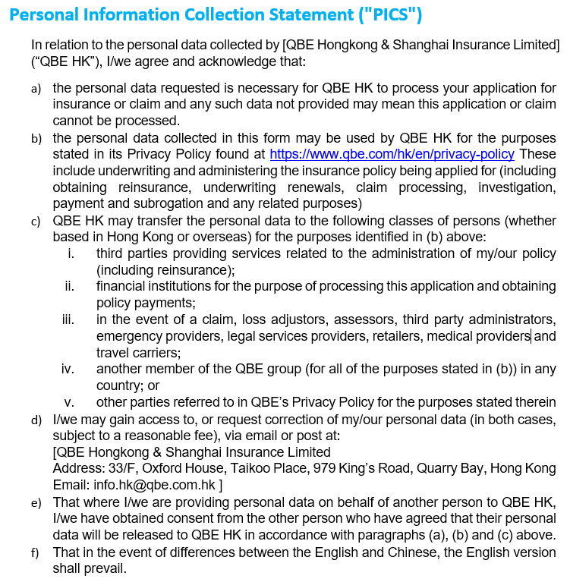
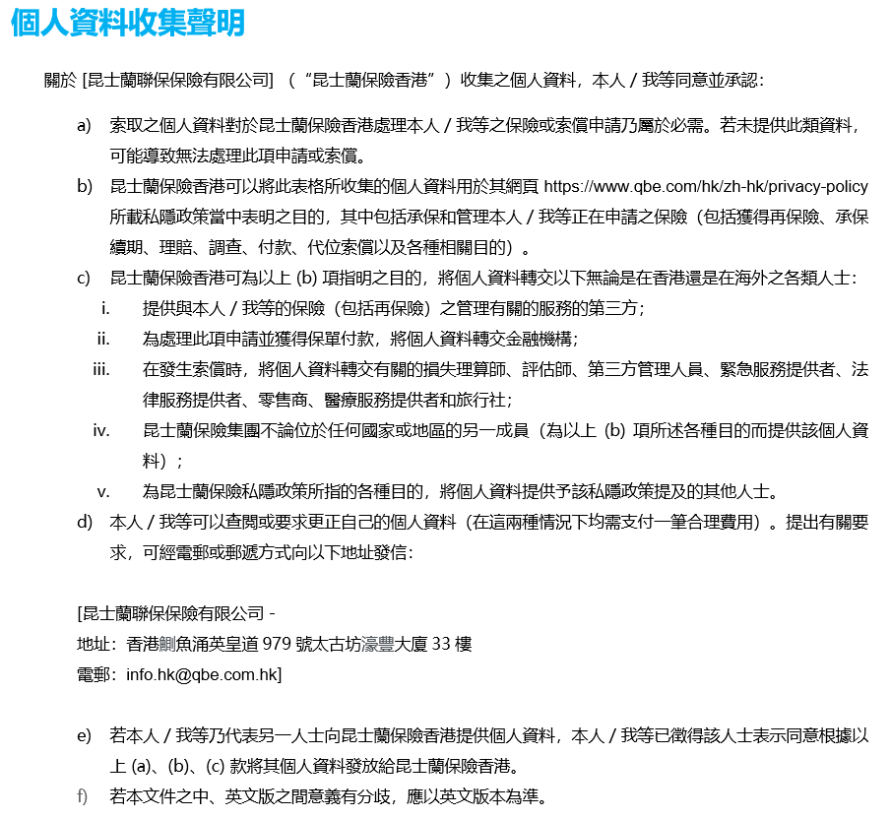CLM.QGI.PHC.V1.1906

